Food waste roll-out Autumn 2024

* **AGLC** (cosy campus area)

* **Main Library** (cosy campus area)

* **Uni Place**

entrance/drum (cosy campus area)

Atrium first floor

* **MECD**

Adj. Collaborate café

Connect café

Adj. north/Grosvenor Street entrance

* **Arthur Lewis** (cosy Campus area)

* **Simon Building** (Benugo café)

* **Stopford**

Reception/food outlet

First floor common area

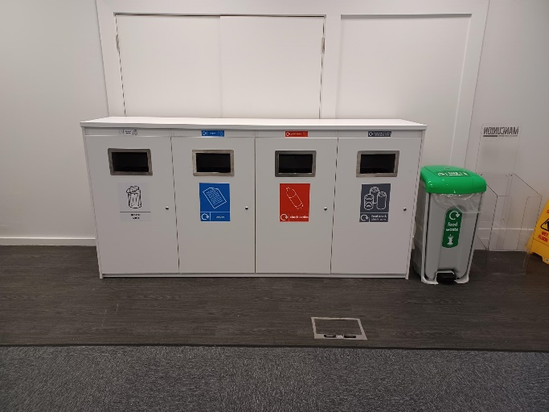

* **AMBS**

Café 65

Hive Café

* **Sam Alex** (Lime café)

* **Schuster** (former café area)

