
Cycle Shelter Locations
South Campus
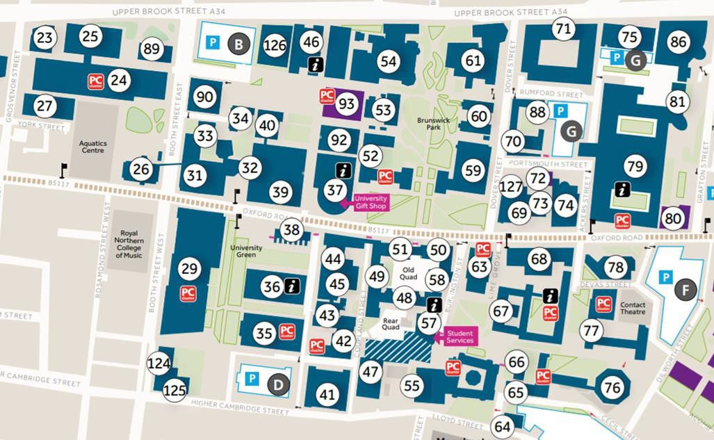
Between the Roscoe
and Williamson
Buildings
On Bridgeford Street,
near the Arthur Lewis Building
At the side of the Alan Gilbert Learning Commons Building on Lime Grove
Within Booth Street West multi-storey car park (entrance on the North side)
At the side of the Stopford Building on Ackers Street
At the rear of the Stopford Building
MECD Active Travel Hub
Outside the
Chemistry Building
Near the Aquatics Car Park, off Booth Street East


Cycle Shelter Locations
North Campus

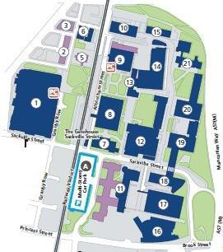
Outside the George Begg Building

