Small electricals and electronics recycling

This is a guide to what can and can’t be placed in the pink bins/caddies used for collecting small electricals and electronics for recycling. For any additional information please e-mail simon.atkinson@manchester.ac.uk

What is allowed
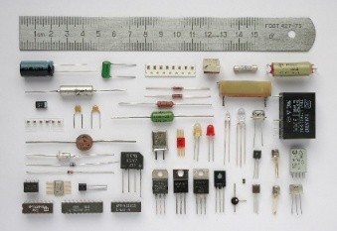 | 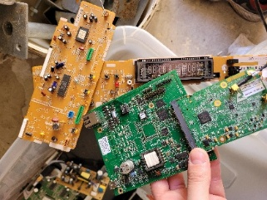 | 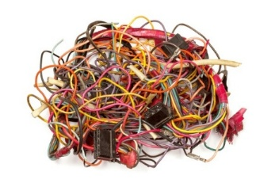 | 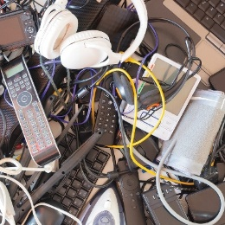
Small components e.g. microcontrollers, resistors, LEDs | PCB’s | Cables and Wires | Small Electrical and electronic items

Not Allowed!
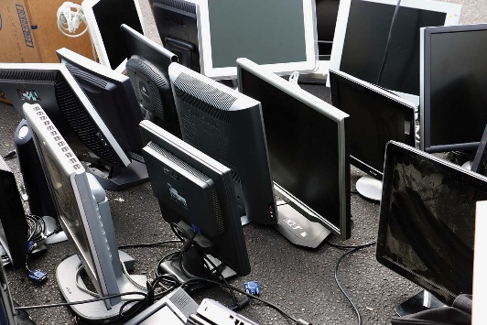 | 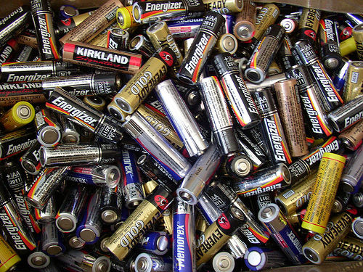 | 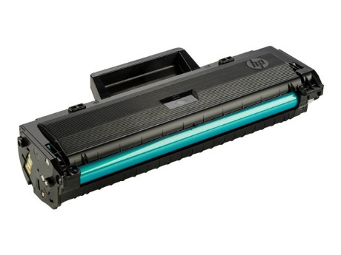
No IT equipment, e.g. Screens, PC’s, or Laptops | No Batteries! | No Toner cartridges
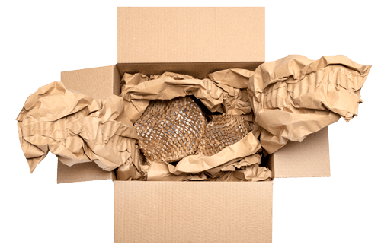 | 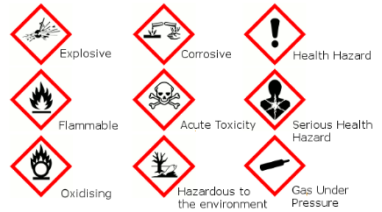 | 
No cardboard, plastic bags, or film used for packaging | Nothing containing hazardous or dangerous items | No Liquid

